**Experiment No. 2**

PART A

(PART A: TO BE REFFERED BY STUDENTS)

A.1 Aim: **Installation of Android Studio and developing simple “Helloworld” app in android studio.**

**A.2 Prerequisite:**

Knowledge of installing any program.

Knowledge of xml and java programming.

**A.3 Outcome:**

After successful completion of this experiment students will be able to

1. Know in detail each and every block of the android architecture.
2. Have knowledge of all the android versions and its main features.
3. Know the idea of sdk manager and AVM.

**A.4 Theory:**

Android Studio provides everything you need to start developing apps for Android, including the Android Studio IDE and the Android SDK tools.

More features of Android Studio:

* Built on IntelliJ IDEA Community Edition, the popular Java IDE by JetBrains.
* Flexible Gradle-based build system.
* Build variants and multiple APK generation.
* Expanded template support for Google Services and various device types.
* Rich layout editor with support for theme editing.
* Lint tools to catch performance, usability, version compatibility, and other problems.
* ProGuard and app-signing capabilities.
* Built-in support for Google Cloud Platform, making it easy to integrate Google Cloud Messaging and App Engine.

System Requirements on Windows platform:

* Microsoft® Windows® 8/7/Vista/2003 (32 or 64-bit)
* 2 GB RAM minimum, 4 GB RAM recommended
* 400 MB hard disk space
* At least 1 GB for Android SDK, emulator system images, and caches
* 1280 x 800 minimum screen resolution
* Java Development Kit (JDK) 7
* Optional for accelerated emulator: Intel® processor with support for Intel® VT-x, Intel® EM64T (Intel® 64), and Execute Disable (XD) Bit functionality

Once android studio is installed then make one simple app of HalloWorld in Android.

The hierarchy of package explorer and use of files of each level is given in below diagram:

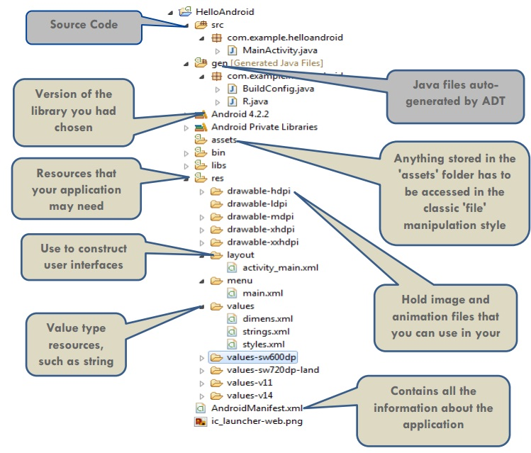

PART B

(PART B: TO BE COMPLETED BY STUDENTS)

**(Students must submit the soft copy as per following segments within two hours of the practical. The soft copy must be uploaded on the Blackboard or emailed to the concerned lab in charge faculties at the end of the practical in case the there is no Black board access available)**

|  |  |
| --- | --- |
| Roll No. B046,B049,B043,B044 | Name: Pranav Joshi,Vedant Sharma, Pragti Kapoor, Abhinav Jaiswal |
| Program: B.tech Computer | Division: B |
| Semester: IV | Batch : B |
| Date of Experiment: 5-2-15 | Date of Submission: 5-2-15 |
| Grade : |  |

B.1 Task to be done:

**1) Install the android studio.**

2) Develop HelloWorld (Basic App) to get familiarize with Android Development kit.

3) Paste HelloWorld code in this section along with output.

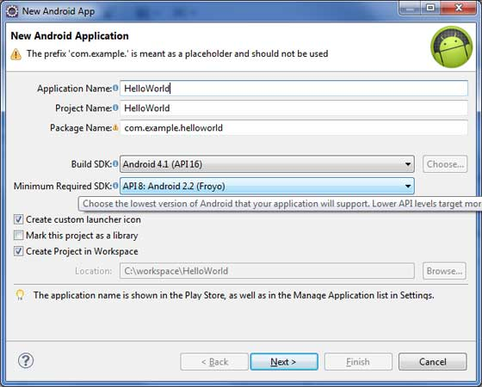

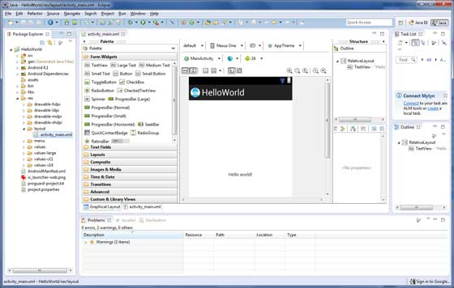

**package com.example.helloworld;**

**import android.os.Bundle;**

**import android.app.Activity;**

**import android.view.Menu;**

**import android.view.MenuItem;**

**import android.support.v4.app.NavUtils;**

**public class MainActivity extends Activity {**

**@Override**

**public void onCreate(Bundle savedInstanceState) {**

**super.onCreate(savedInstanceState);**

**setContentView(R.layout.activity_main);**

**}**

**@Override**

**public boolean onCreateOptionsMenu(Menu menu) {**

**getMenuInflater().inflate(R.menu.activity_main, menu);**

**return true;**

**}**

**}**

**<manifest xmlns:android="http://schemas.android.com/apk/res/android"**

**package="com.example.helloworld"**

**android:versionCode="1"**

**android:versionName="1.0" >**

**<uses-sdk**

**android:minSdkVersion="8"**

**android:targetSdkVersion="15" />**

**<application**

**android:icon="@drawable/ic_launcher"**

**android:label="@string/app_name"**

**android:theme="@style/AppTheme" >**

**<activity**

**android:name=".MainActivity"**

**android:label="@string/title_activity_main" >**

**<intent-filter>**

**<action android:name="android.intent.action.MAIN" />**

**<category android:name="android.intent.category.LAUNCHER"/>**

**</intent-filter>**

**</activity>**

**</application>**

**</manifest>**

**package com.example.helloworld;**

**public final class R {**

**public static final class attr {**

**}**

**public static final class dimen {**

**public static final int padding_large=0x7f040002;**

**public static final int padding_medium=0x7f040001;**

**public static final int padding_small=0x7f040000;**

**}**

**public static final class drawable {**

**public static final int ic_action_search=0x7f020000;**

**public static final int ic_launcher=0x7f020001;**

**}**

**public static final class id {**

**public static final int menu_settings=0x7f080000;**

**}**

**public static final class layout {**

**public static final int activity_main=0x7f030000;**

**}**

**public static final class menu {**

**public static final int activity_main=0x7f070000;**

**}**

**public static final class string {**

**public static final int app_name=0x7f050000;**

**public static final int hello_world=0x7f050001;**

**public static final int menu_settings=0x7f050002;**

**public static final int title_activity_main=0x7f050003;**

**}**

**public static final class style {**

**public static final int AppTheme=0x7f060000;**

**}**

**}**

**OUTPUT:**

